Student Performance Prediction System

Project Id: AIML-6

Name : Nakshatra Agarwal (Team Leader)
Class Roll Number:55
University Roll Number :2028775
Section and Group: P G2

Name : Manvi Arora
Class Roll Number:52
University Roll Number : 2028761
Section and Group: P G2

Name : Ruhee Gupta
Class Roll Number:63
University Roll Number : 2028829
Section and Group: P G2

TABLE OF CONTENTS
- Problem Description 3
  - Dataset Description 3
  - Flow diagram 4
- Modules for Project Implementation…………………..…………………………5
  - Modules Used 5
  - Platform Used 6
- Machine Learning model/ Searching Technique used 7
- Evaluation metrics used 8
- Results and Visualizations 9
- Conclusion and Future Scope 11
- References 12

- Problem Description
- Urban water demand varies significantly due to factors such as household size, seasonal conditions, and outdoor water usage like gardening. Accurately predicting daily water consumption is essential for efficient resource allocation, reducing wastage, and ensuring sustainable urban planning. However, traditional estimation approaches often fail to capture these dynamic relationships and variations present in real-world data.
- This project focuses on developing a data-driven predictive model to estimate daily water usage using a curated dataset containing features such as Household_Size, Seasonal_Index, and Garden_Area. The dataset includes realistic characteristics such as missing values and variability, requiring preprocessing techniques like data cleaning and outlier handling to ensure data quality.
- Feature scaling using StandardScaler is applied to normalize the data, enabling fair contribution of all features during model training. A Linear Regression algorithm is then used to model the relationship between input variables and the target variable, Daily_Liters_Used. The model’s performance is evaluated using statistical metrics and residual analysis to ensure reliability and accuracy.
- The outcome of this project provides insights into water consumption patterns and demonstrates how machine learning can support efficient water resource management in urban environments.

  - Dataset Description

The dataset used in this project is a synthetically generated dataset designed to simulate real-world urban water consumption patterns. It consists of approximately 200,000 records, providing a large and diverse sample for training and evaluating the machine learning model.
Features (Independent Variables):
- Household_Size:
Represents the number of individuals living in a household. This is an integer-valued feature, typically ranging from 1 to 7. Larger households generally lead to higher water consumption due to increased daily usage activities.
- Seasonal_Index:
A continuous numerical feature representing the impact of seasonal variations on water usage. It ranges approximately between 0.7 and 1.6, where lower values indicate seasons with lower water demand (e.g., winter), and higher values indicate increased usage (e.g., summer).
- Garden_Area:
A continuous variable representing the size of the garden or outdoor area associated with a household. It ranges from 0 to 100 (in square units), where larger areas require more water for irrigation purposes.

Target Variable (Dependent Variable):
- Daily_Liters_Used:
Represents the total amount of water consumed per day in liters. This is a continuous variable calculated based on a combination of input features along with a small amount of random noise to simulate real-world variability.

Dataset Characteristics:
- The dataset contains random decimal values to reflect realistic variations in measurements.
- Approximately 5% missing (null) values are intentionally introduced across all columns to simulate incomplete real-world data.
- Outliers have been removed using the Interquartile Range (IQR) method to ensure data consistency and improve model performance.
- The dataset is stored in CSV format, making it easy to load and process using data analysis libraries.

1.2 Flow Diagram

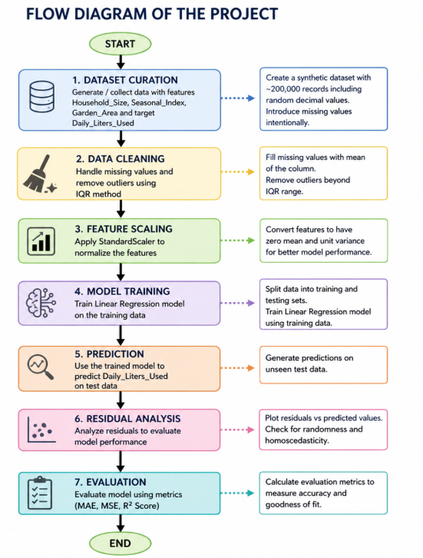

2. Modules for Project Implementation

2.1 Modules Used(mention all the inbuilt/ custom modules used and the purpose)

1. Pandas
Pandas is used for data handling and manipulation. It provides DataFrame structures for organizing and processing datasets.
Functions Used:
- pd.read_csv() → Load dataset from CSV file
- df.head() → View initial rows of dataset
- df.fillna() → Handle missing values
- df.drop() → Remove unwanted data
- df.describe() → Generate statistical summary

2. NumPy
NumPy is used for numerical computations and efficient handling of arrays.
Functions Used:
- np.array() → Create arrays
- np.mean() → Calculate average values
- np.std() → Calculate standard deviation
- np.random() → Generate random data

3. Scikit-learn (sklearn)
Scikit-learn is the main library used for implementing machine learning models and preprocessing techniques.
Modules Used:
- StandardScaler → Used for feature scaling
- train_test_split → Splits dataset into training and testing sets
- LinearRegression → Baseline regression model
- DecisionTreeRegressor → Tree-based model for non-linear patterns
- RandomForestRegressor → Ensemble model for improved accuracy
- SVR → Support Vector Regression for complex relationships
- metrics → Used to evaluate model performance (MAE, MSE, R²)

4. Matplotlib
Matplotlib is used for basic data visualization and plotting graphs.
Functions Used:
- plt.scatter() → Plot actual vs predicted values
- plt.plot() → Plot regression lines
- plt.xlabel(), plt.ylabel() → Label axes
- plt.show() → Display plots

5. Seaborn
Seaborn is used for advanced statistical visualizations.
Functions Used:
- sns.heatmap() → Display correlation matrix
- sns.scatterplot() → Visualize feature relationships
- sns.histplot() → Show distribution of data

6. Built-in Python Functions
Basic Python functions are used for data handling, looping, and logical operations.

2.2 Platform Used: (mention all the platforms with the reason of using it)
  - Visual Studio Code: For code writing, testing, and debugging.
VS Code is equipped with multiple extensions, debugger which enhance the development experience.

Machine Learning Model/ Searching Technique Used(Describe each ML model/ searching technique used)
In this project, multiple machine learning models were implemented and compared to predict daily water consumption. Using multiple models helps in identifying the most accurate and reliable approach.

1. Linear Regression
Linear Regression is a supervised learning algorithm used for predicting continuous values. It models a linear relationship between input features and the target variable.
Working:
- Finds best-fit line
- Minimizes prediction error
Why Used:
- Simple and interpretable
- Baseline model for comparison

2. Decision Tree Regressor
Decision Tree is a non-linear model that splits data into smaller subsets based on feature values.
Working:
- Creates tree-like structure
- Splits data based on conditions
Why Used:
- Handles non-linear relationships
- Easy to visualize

3. Random Forest Regressor
Random Forest is an ensemble learning method that uses multiple decision trees to improve accuracy.
Working:
- Builds multiple trees
- Combines their outputs (average)
Why Used:
- Reduces overfitting
- Provides better accuracy than single tree

4. Support Vector Regression (SVR) (or replace with your actual model if different)
SVR is used for regression tasks and tries to fit data within a margin of tolerance.
Working:
- Finds best boundary within margin
- Focuses on critical data points
Why Used:
- Works well with complex patterns
- Handles high-dimensional data

Model Comparison (Important for marks)
- Linear Regression → Simple baseline
- Decision Tree → Captures non-linearity
- Random Forest → Improves accuracy
- SVR → Handles complex relationships
Best model is selected based on evaluation metrics (MAE, MSE, R²)

4. Evaluation metrics used (Describe each evaluation metric used along with formulae)
To evaluate the performance of the machine learning models, several regression evaluation metrics are used. These metrics help in measuring how close the predicted values are to the actual values.

1. Mean Absolute Error (MAE)
Definition:
Mean Absolute Error measures the average absolute difference between actual and predicted values.
$$MAE=\frac{1}{n}∑∣y-\hat{y}∣$$
Where:
- $y$= Actual value
- $\hat{y}$= Predicted value
- $n$= Number of observations
Interpretation:
- Gives error in the same unit (liters)
- Easy to understand
- Lower value indicates better performance

2. Mean Squared Error (MSE)
Definition:
Mean Squared Error calculates the average of squared differences between actual and predicted values.
$$MSE=\frac{1}{n}∑(y-\hat{y})^{2}$$
Interpretation:
- Penalizes large errors more heavily
- Sensitive to outliers
- Lower value indicates better model

3. Root Mean Squared Error (RMSE)
Definition:
RMSE is the square root of MSE and represents error in original units.
$$RMSE=\sqrt{MSE}$$
Interpretation:
- More interpretable than MSE
- Shows standard deviation of errors
- Lower value is better

4. R² Score (Coefficient of Determination)
Definition:
R² measures how well the model explains the variation in the data.
$$R^{2}=1-\frac{∑(y-\hat{y})^{2}}{∑(y-\overset{ˉ}{y})^{2}}$$
Where:
- $\overset{ˉ}{y}$= Mean of actual values
Interpretation:
- R² = 1 → Perfect model
- R² = 0 → No predictive power
- R² < 0 → Poor model

5. Results and Visualizations
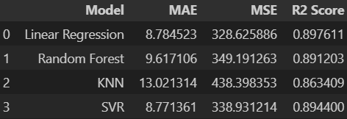
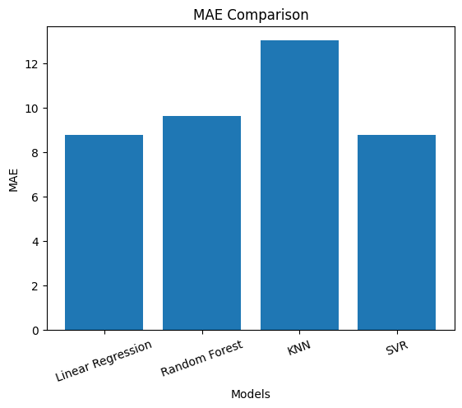
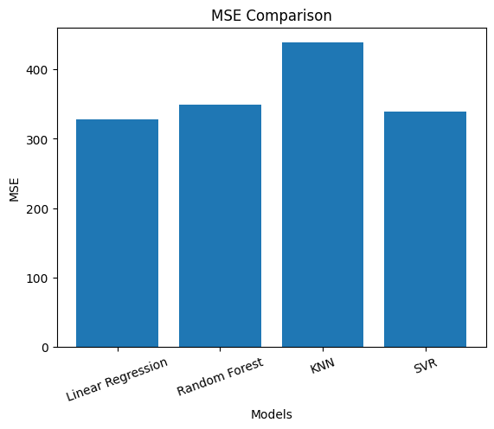
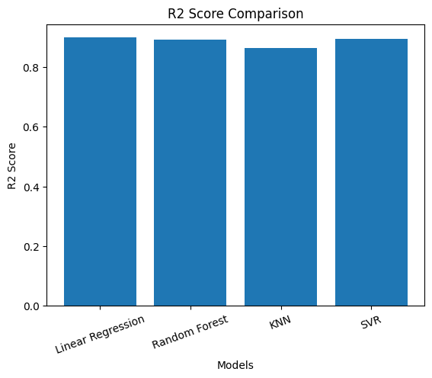
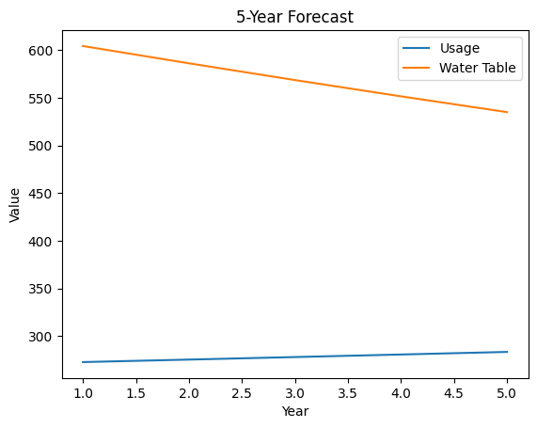
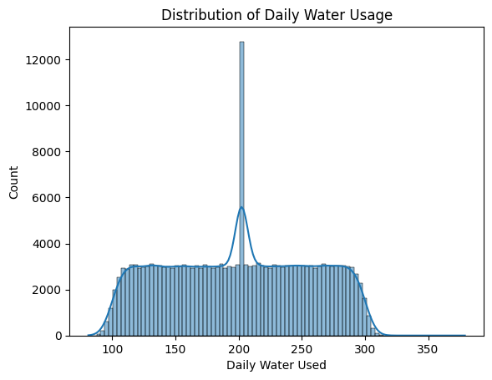
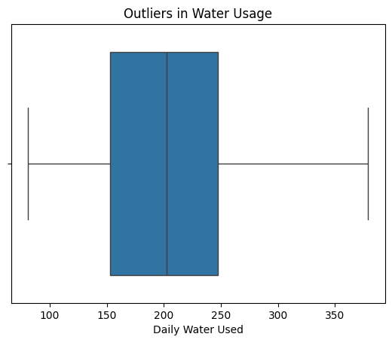
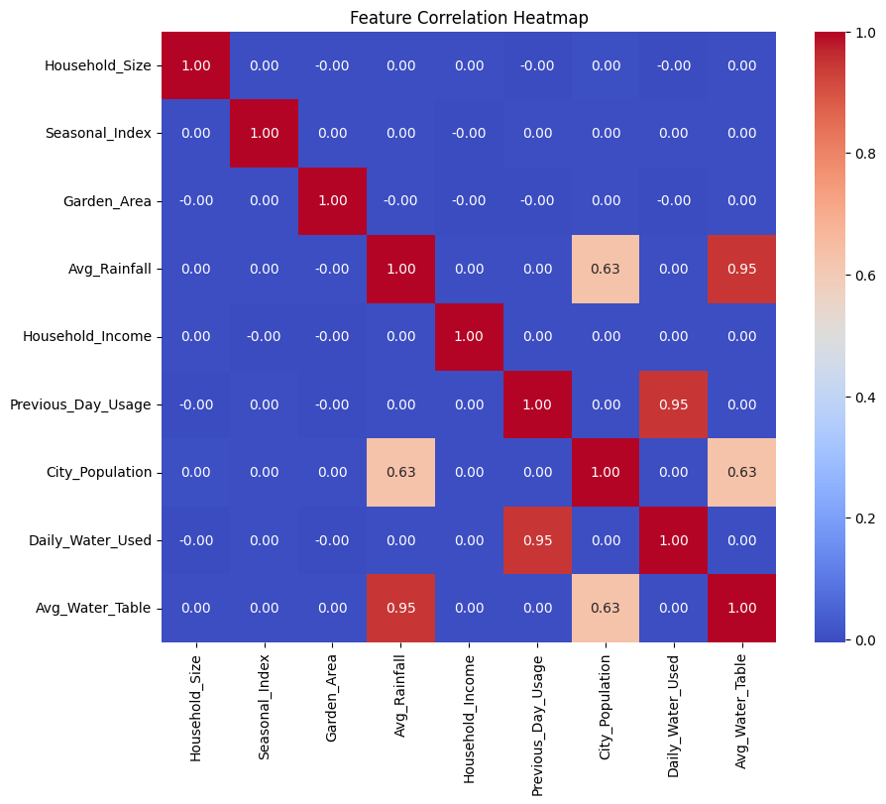

6. Conclusion and Future Scope:
This project successfully demonstrates the application of machine learning techniques in predicting urban water demand. By utilizing key features such as household size, seasonal index, and garden area, a structured dataset was developed to model real-world water consumption patterns. Data preprocessing steps, including handling missing values and feature scaling using StandardScaler, ensured improved data quality and model performance.
Multiple machine learning models were implemented and compared, including Linear Regression, Decision Tree, Random Forest, and Support Vector Regression. Among these, ensemble and non-linear models showed improved performance over basic linear models, highlighting the importance of model selection in predictive analytics.
Evaluation metrics such as MAE, MSE, RMSE, and R² score were used to assess model accuracy. Residual analysis confirmed that the chosen model provides reliable predictions with minimal error patterns. Overall, the project proves that data-driven approaches can significantly enhance decision-making in urban water resource management.

Future Scope
- Use of Advanced Algorithms:
Implement more advanced models such as XGBoost or Neural Networks for improved prediction accuracy.
- Integration of Real-Time Data:
Incorporate IoT sensor data and smart meters to enable real-time water demand forecasting.
- Inclusion of Additional Features:
Add factors like rainfall, temperature, income levels, and population density for better prediction.
- Deployment as a Web Application:
Develop a web-based or mobile application for real-time predictions and visualization.
- Scalability for Smart Cities:
Extend the system to support large-scale smart city infrastructure and automated water management systems.
7. References:
Books:
- Let Us Python – Yashavant Kanetkar

Online Resources:
  - GeeksforGeeks – https://www.geeksforgeeks.org/
  - TutorialsPoint – https://www.tutorialspoint.com/cprogramming/index.htm
  - Stack Overflow – https://stackoverflow.com

